# Unit 4 Homework - Linux

Julie Haynes

Set Permissions. Used chmod.











Create User Accounts. Used “Adduser”

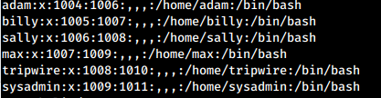

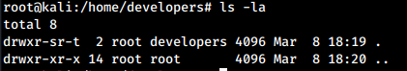

Modify common-password file to force password to use 16 chars minimum with 1 lowercase, 1 uppercase, 1 number, 1 special character. Used “sudo apt-get install libpam-cracklib. Make backup file of “common-password” then modified “common-password”



Require password change every 90 days. Used “chage” (example: “chage -M 90 billy”)

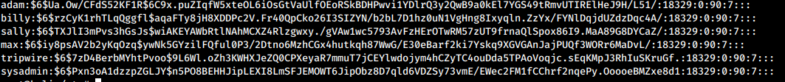

Create “developers” user group and add 4 users. Used “groupadd” and “usermod” (example: “usermode -aG developers adam)

 in /etc/passwd

 in /etc/group

Add sticky bit and GUID. Used chmod. (example: “chmod +t developers” and “chmod g+s developers”). View with command ls -ld.



Make developers dir (mkdir) and change group on directory to developers. Used chown. (example: “chown :developers developers”) View with stat command.

